UML DIAGRAMS

*FASTO Couriers - “Connecting lives”*

**Submitted By:**

**Stephy Grace Oommen**

**S9 INT MCA ROLL NO: 51**

1. USECASE DIAGRAM

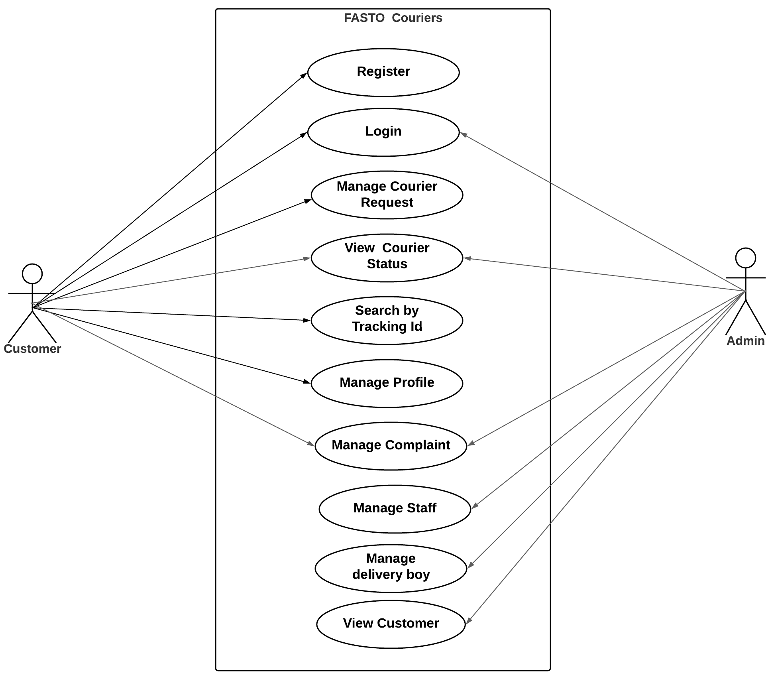

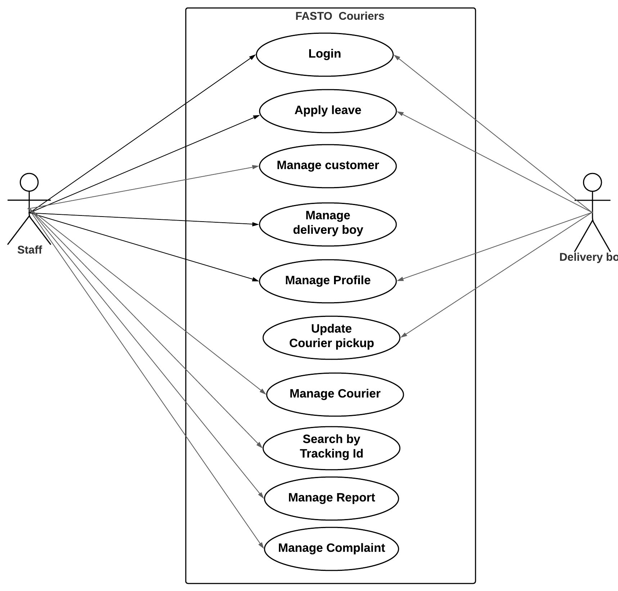

2. ACTIVITY DIAGRAM for login

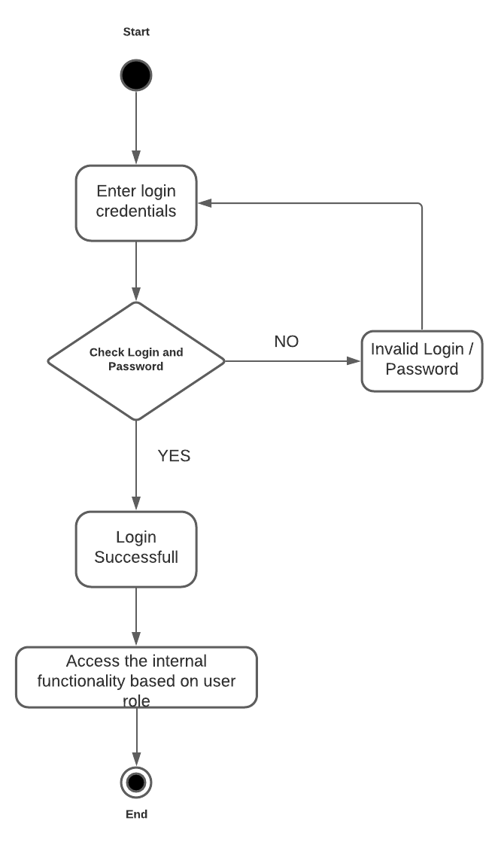

3. STATECHART DIAGRAM FOR SENDING COURIER

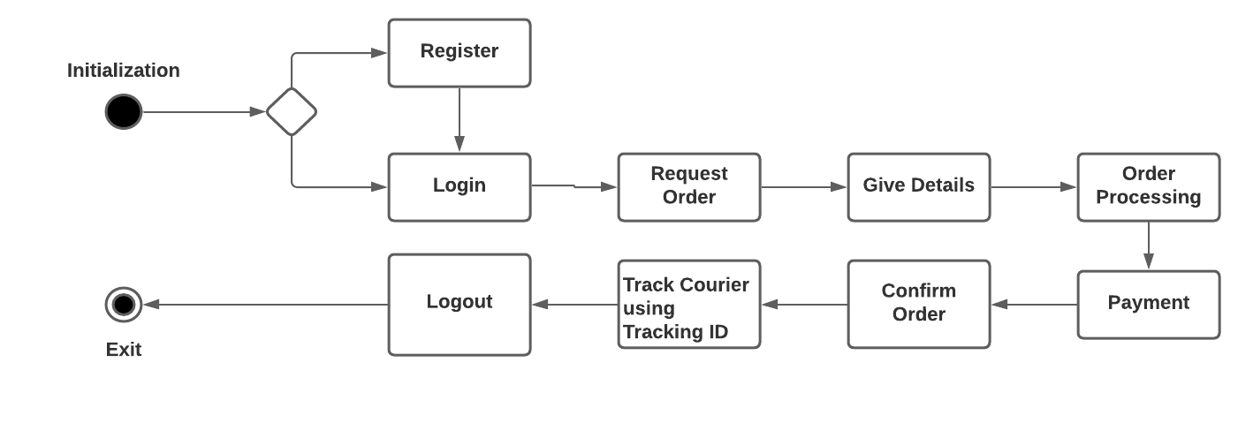

4. COMPONENT DIAGRAM

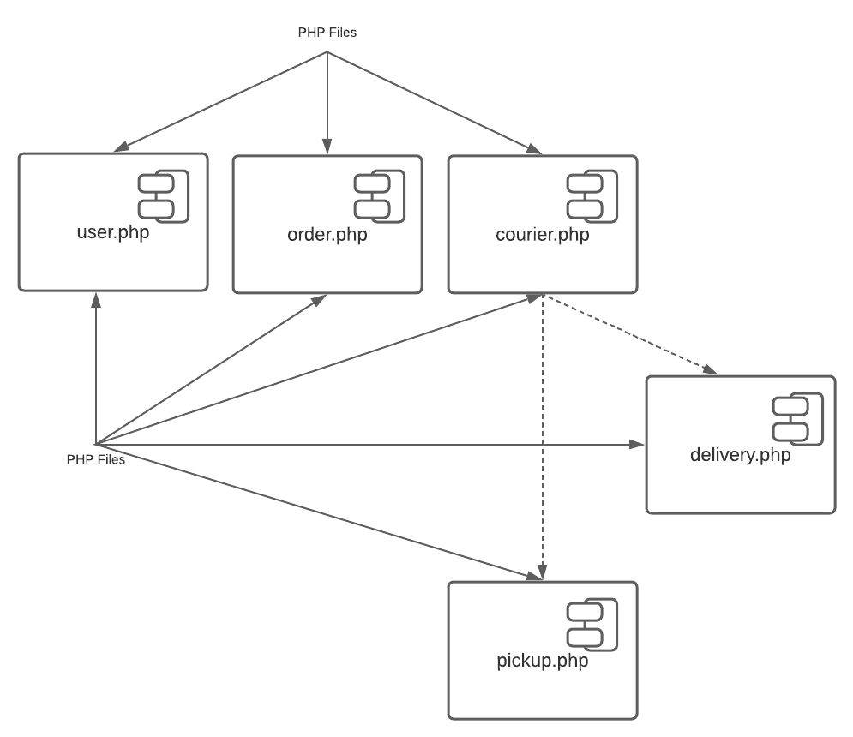

4. SEQUENCE DIAGRAM for searching courier using Tracking Id

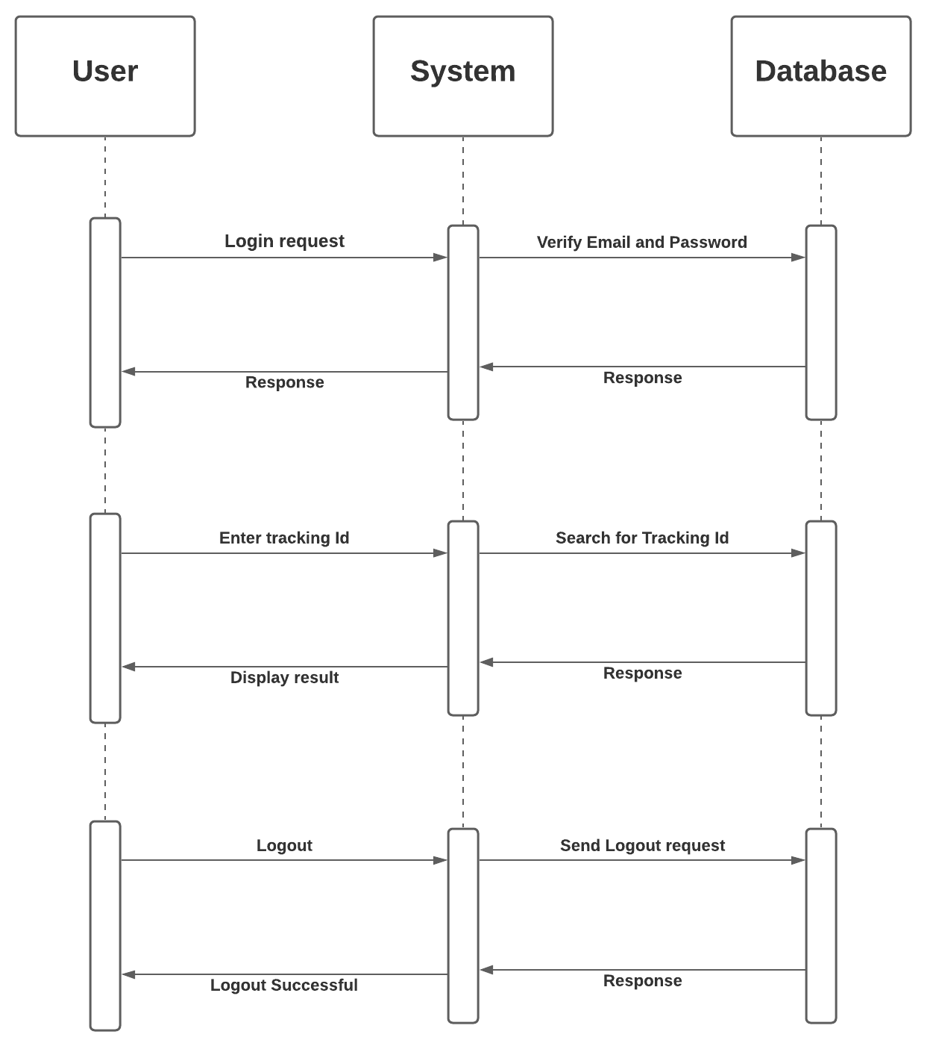

6. DEPLOYMENT DIAGRAM

